Walk 1 Cossall Village
5.3 miles.
This is a circular walk to the lovely and historically interesting village of Cossall. It will take about two and a half hours at a gentle pace. The walk is along unspoilt lanes, tracks and paths over farmland and along the towpath of the old Nottingham canal. Mainly good going underfoot but walking boots or good quality shoes are recommended. See the attached sketch of the route.
- Turn left out of Strelley Hall and walk along the lane. Look for the information board on your left that explains the history of the Stones of the Monks Way. Carry on along the lane past the church to the sharp left hand bend and take the track on the right.
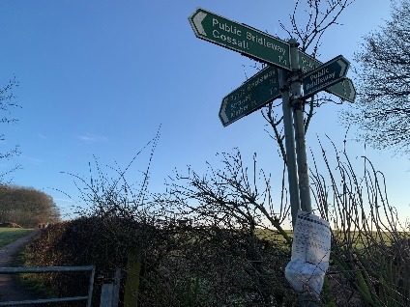
- Carry on along the track, tall trees and a bank appear on your right, when the trees end look out for a path on the right. Take this. On your left is a good view over Nottingham with Wollaton Hall clearly visible. You will come to a wood on the right, then an open field and once you are near the hedgerow in front you will see a crossroad of tracks with Cossall indicated to the right. Turn right.
- You will now have good views over Derbyshire in front of you. Carry on and zigzag your way under the M1. Once the track straightens out just keep on going, Oldmoor Wood will be to the right over the field and the water tower at Swingate can be seen on the horizon. The path twists and turns a little but just follow it to the end.
- You have now reached the road leading to Cossall. Watch for traffic and cross the road to the wooden gate leading to the canal path. Keep on this path, it bends to the right and leads to a bridge over the canal. Take this bridge and turn right, the canal will now be on your right as you walk along. Another bridge comes into view after the left hand bend, go over this and walk straight up the field towards farm buildings.
- Go through the gate and over the track slightly to the right to join another path. This follows a fence and leads to the main road passing through Cossall. Watch for traffic and turn right. Appearing on your left will be the Almshouses built in 1685. Next door is the old village school house, built by Lord Middleton in 1813, the porch was added in 1850. It is now a recently refurbished and extended village hall. The cottage next door was occupied by Louis Burrows who was the fiancée of D.H. Lawrence and it is mentioned in his book, The Rainbow. Pay a visit to St Catherine’s Church and see the monument to two villagers who fought at Waterloo.
- On leaving the church turn left and continue down the road, keeping on the pavement. Turn the left hand bend and at the next right hand bend keep straight on along Robinettes Lane. Open fields on the right and a few houses on the left. After a while a cottage appears set back, on its own on the right. This is Keepers Cottage, possibly the inspiration for Lady Chatterley’s Lover. Go on past this at the start of the bend in the lane there is a footpath in the hedgerow on the right.
- After going through the metal gate do not go over the wooden style. This route is overgrown and not safe to walk along. Look diagonally over the field and just to the right of the tree you will see a yellow topped post and a metal kissing gate, this is the official right of way, head towards this and go through the gate. Keep straight on to the corner of the field and go through the kissing gate there. Carry on up the track to join the main lane at a crossroads.
- Turn right and follow the fence alongside the horse field. This path widens out after a while and Holly Copse appears on your left with a view over to Oldmoor Wood on your right. Keep on over the M1 to join the main lane through Strelley village. Cross the road back into Strelley Hall and Mulberry Tree Café for refreshments.

Walk starts at Strelley Hall

