Walk 3 Oldmoor Wood
1.5-2 miles depending on route taken.
This walk will take an hour to an hour and a half. Take care on the lane leading to the wood as it is difficult to hear approaching traffic due to the noise of the M1. Good grip shoes or boots are needed as the route is uneven in places and wet and slippery at times. The only hill is the very gradual slop upward as you leave the wood.
The attached sketch shows the long route and several short cuts if required.
- Fron the main gates of Strelley Hall, cross over Main street and follow the lane opposite. Go over the M1 and continue past the Notts Angler’s Gate for another 100m to the Woodland Trust inlet on the left. This leads down to the wood.
- Enter the wood and continue along the main track. This main track will take you the full length of the wood. Check the sketched route.
- Continue walking along the main track for about 300m and towards the end a fence and open fields begin to emerge. You will see a small pond on the right, carry on for a further 50m and take a thin path on the right as you near the fence to the open field.
- Stay on the thin path for 100m as it gradually bends right and follow it back up through the wood.
- Keep on this path and after about 200m you will come to a T-junction and see an entrance to the wood on the left leading to an open field. Turn right here and immediately take the tin path forking left. This part of the route is marked with white-topped posts. It weaves through the trees and ends at the bank of the old ornamental pond. Turn right at the pond and after a few metres you will re-join the main path through the wood. Turn left and continue up out of the wood back to the lane.
- Turn right and walk back down the lane over the M1 to the Mulberry Tree Café.
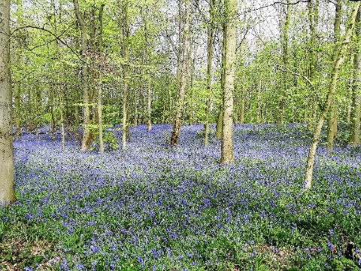
The bluebells in Oldmoor Wood

